**Parity Generator and Checker:**

What is a Parity Bit?

A parity bit is a binary digit added to a set of data bits to help detect errors in data transmission or storage. It ensures that the total number of 1s in the data is either even (even parity) or odd (odd parity), depending on the chosen scheme.

**Parity Generator:**

A parity generator is a combinational logic circuit that adds a parity bit to a given binary message to ensure error detection during data transmission.

It does not correct errors, but helps detect single-bit errors.

It is of two types:

* Even parity generator.
* Odd parity generator.

**Even Parity generator:**

An even parity generator adds a parity bit such that the total number of 1’s (data bits + parity bit) is even.

P_even = A ⊕ B ⊕ C ⊕ D

**Odd parity generator:**

An odd parity generator adds a parity bit such that the total number of 1’s (data bits + parity bit) is odd.

P_odd = ¬(A ⊕ B ⊕ C ⊕ D)

**Truthtable:**

**Implemented Parity generators using Verilog on Xilinx vivado:**

**1.Even parity generator(data flow modelling):**

**Design**:

**Test Bench:**

**2.Odd parity generator(behavioural modelling):**

**Design:**

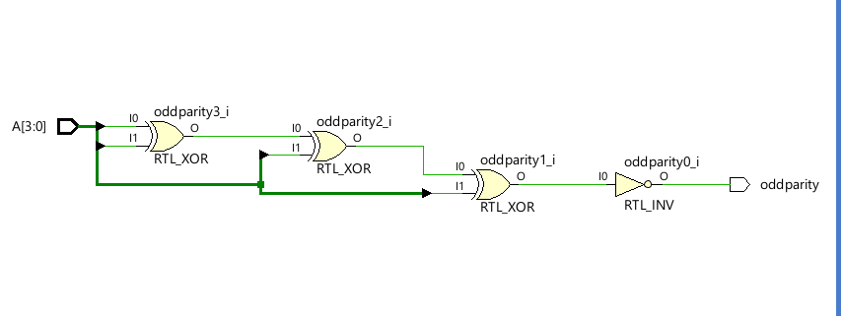

**Test bench:**

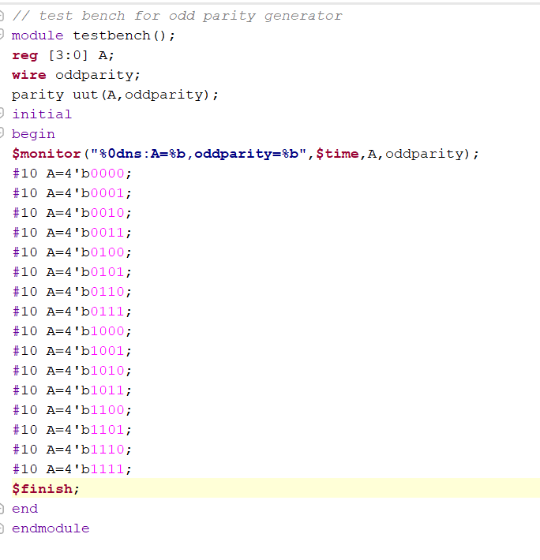

**Parity checker:**

A parity checker is a combinational logic circuit used at the receiver end to detect errors in transmitted data. It checks whether the received data (including the parity bit) conforms to the expected parity (even or odd).

It does not correct errors, only detects them.

It outputs a ‘0’ (no error) if parity is correct and ‘1’ (error) if parity is violated.

It is of two types:

* Even parity checker.
* Odd parity checker.

**1. Even Parity Checker**

Checks if the total number of 1’s in the received data (including parity bit) is even.

If total 1’s are even → no error

If total 1’s are odd → error detected

Check_even = A ⊕ B ⊕ C ⊕ D ⊕ P

**2.Odd Parity Checker**

Checks if the total number of 1’s in the received data (including parity bit) is odd.

If total 1’s are odd → no error

If total 1’s are even → error detected

Check_odd =~( A ⊕ B ⊕ C ⊕ D ⊕ P)

**IC 74180 9-Bit Parity Generators/Checkers**

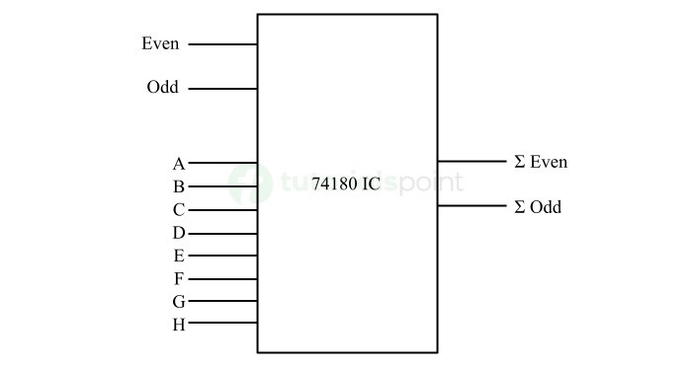

**Implemented parity checkers using Verilog:**

**1.Even parity checker(data flow modelling):**

**Design:**

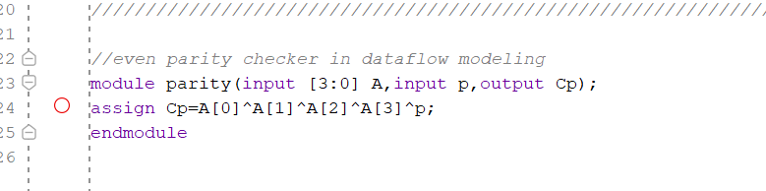

**Test bench:**

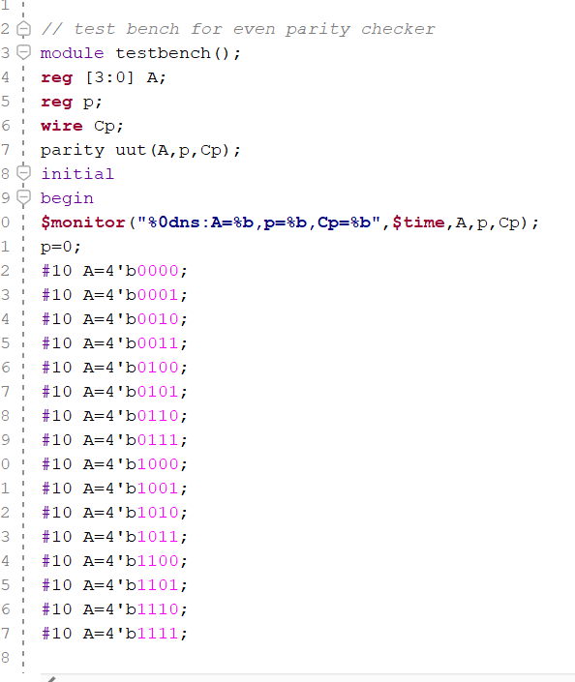

**2.Odd parity chcker(behavioural modelling):**

**Design:**

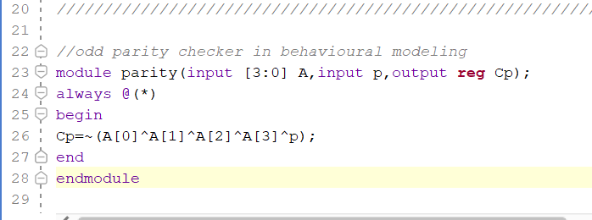

**Test bench:**

